**YEARBOOKS ARE NOW ON SALE. ORDER A COPY TODAY!**

Buy your **SURRY Co. HIGH SCHOOL** yearbook for only **$55**

By **March 22nd 2024!**

NAME (PLEASE PRINT)

# PERSONALIZE YOUR YEARBOOK

Please print your name as you would like it to appear on the first line of your Name Plate below. The maximum number of characters is 30 per line, including spaces.

|  |  |  |  |  |  |  |  |  |  |  |  |  |  |  |  |  |  |  |  |  |  |  |  |  |  |  |  |  |  |
| --- | --- | --- | --- | --- | --- | --- | --- | --- | --- | --- | --- | --- | --- | --- | --- | --- | --- | --- | --- | --- | --- | --- | --- | --- | --- | --- | --- | --- | --- |
|  |  |  |  |  |  |  |  |  |  |  |  |  |  |  |  |  |  |  |  |  |  |  |  |  |  |  |  |  |  |

# ORDER YOUR YEARBOOK

I want to order: (check one)

My yearbook only ($55.00)

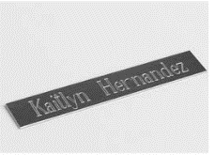Name Plate ($5.00)

World Yearbook ($5.00)

(This is a current event insert) 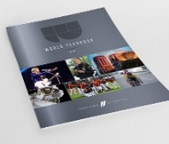

Return this order form with cash or check for the amount shown to **the Main Office**.

## Please make your check out to SURRY COUNTY HIGH SCHOOL for the main office.

## I have included a check for: $ _ .

Check Number:

Cash: _________________

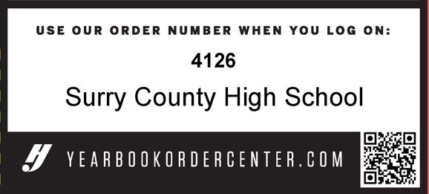

You may also go to [www.yearbookordercenter.com](http://www.yearbookordercenter.com) Order #4126 to purchase online!